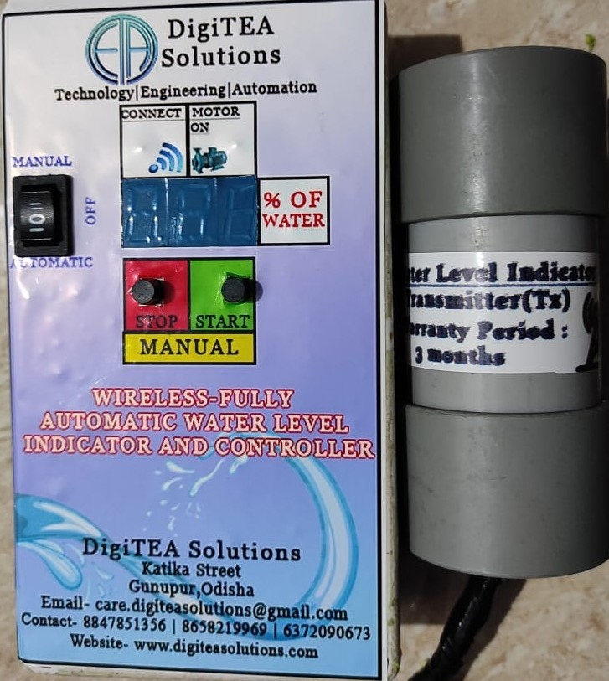**WIRELESS WATER LEVEL INDICATOR AND CONTROLLER**

* Wireless connection between Transmitter and Receiver circuits is used.
* Transmitter and receiver circuit are used at tank and motor switch/control panel respectively.
* The establishment of wireless connection between both Tx and Rx circuits will be displayed by Green LED Light with blinking.
* If the motor will be on then white colour LED will be on.
* LED Display at receiver circuit which displays the level of the tank.
* 10 Level sensors made of brass are used for indication of water tank.
* Both Automatic & Manual mode are present.
* If the level of tank is less than 30% then the motor of the tank will be automatically on until the tank level is full.
* If the tank is full then the motor will be automatically off after 3sec.
* If we want the fresh water even the tank is full then we can fill the water by making the circuit in manual mode.
* 6 months warranty is given to both circuits.

For any information u can contact these 3 numbers:

8847851356

6372090673

8658219969